PROJECT 1: WEB SERVER IN WINDOWS INSTANCE

1. Windows IPV4:2.136.11.156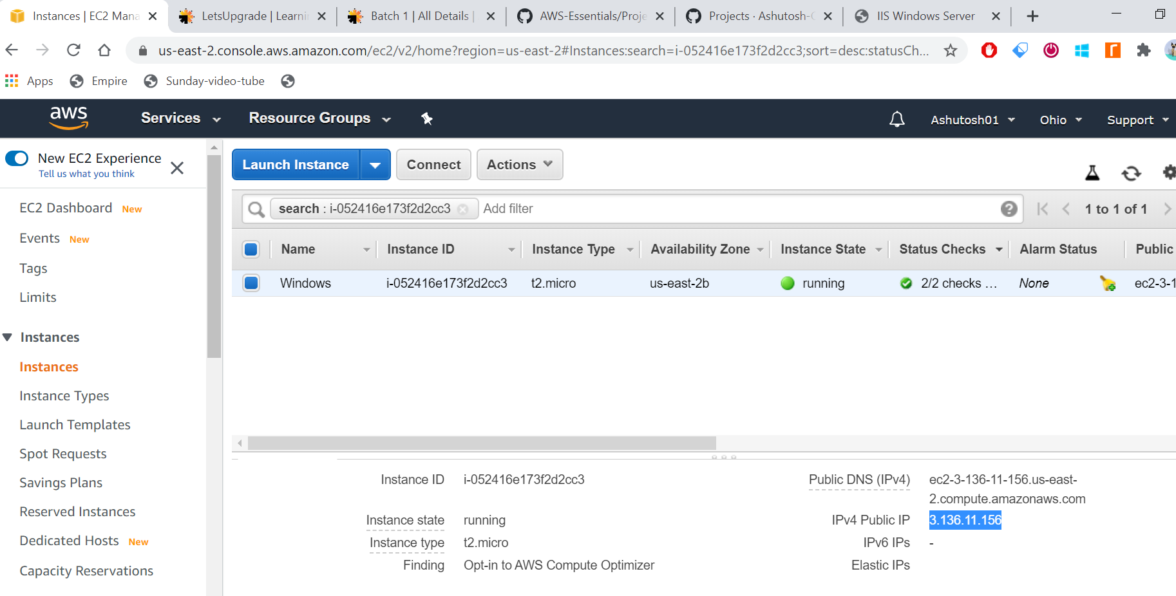

2. IIS Web Server SSH via [3.136.11.156](http://3.136.11.156/)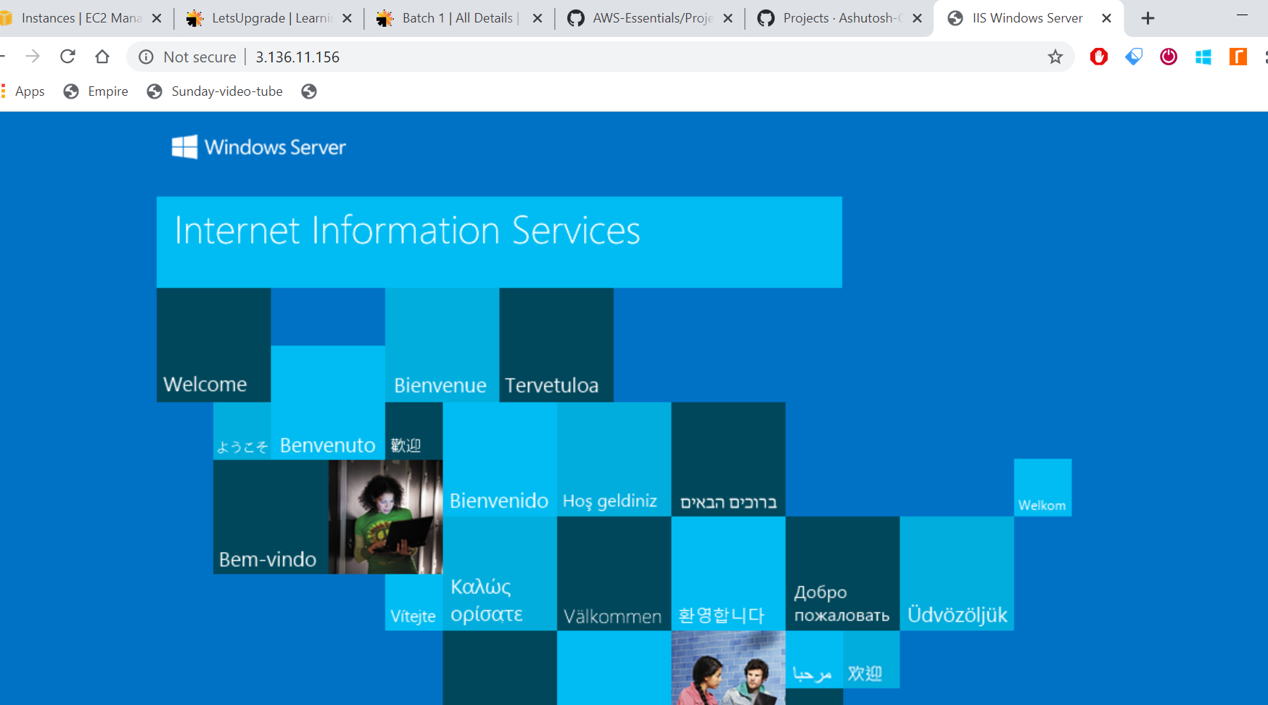

2.Linux IPV4: 18.218.71.120  
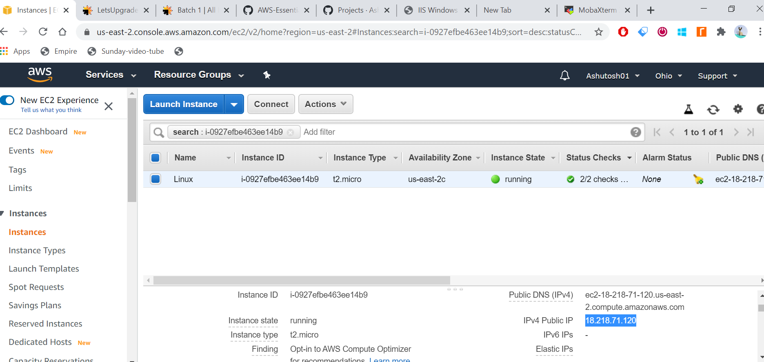

PROJECT 2 : WEB SERVER IN UBUNTU INSTANCE

3. UBUNTU IPV4: [18.189.195.63](http://18.189.195.63/)

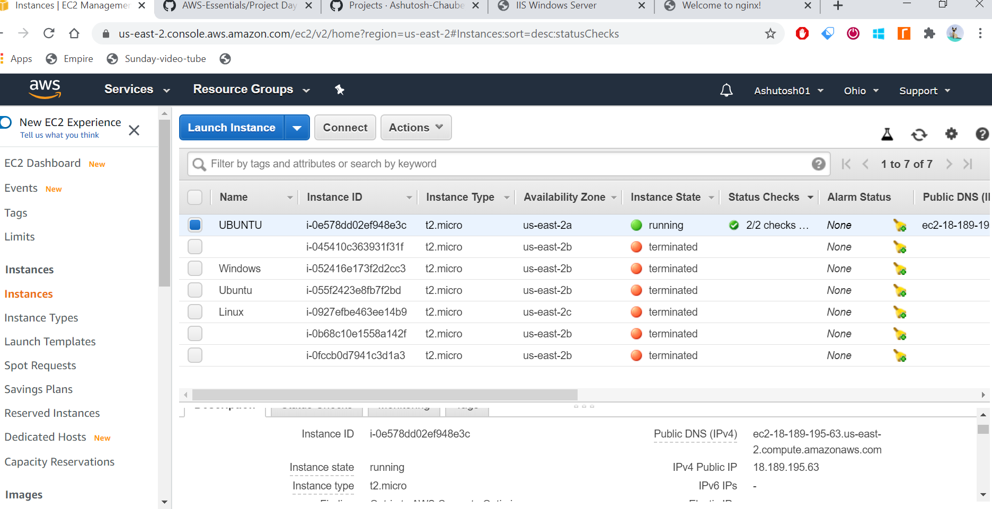

4.3 nginx web page SSH via [18.189.195.63](http://18.189.195.63/)  
